**USER Information Table**

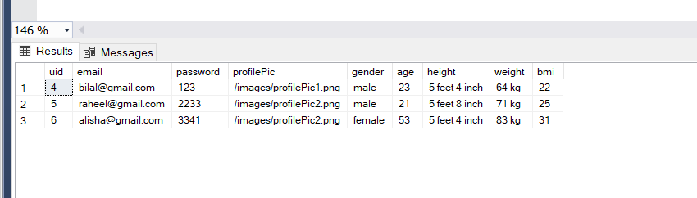

**Progress Pics Table**

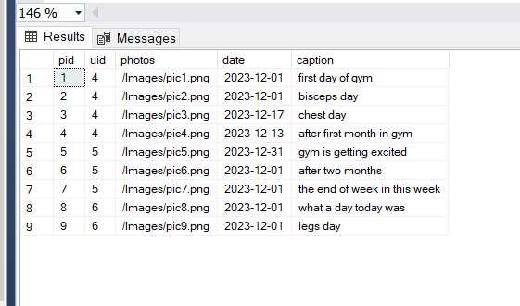

**Exer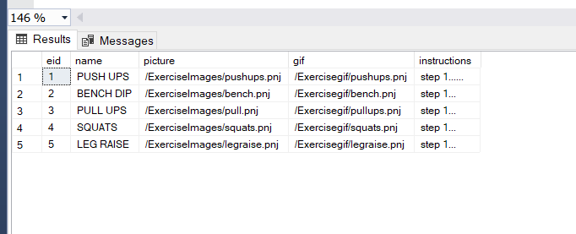cises Table**